Final project report for COMM5961

1155119629 Ma Zhuoer

***Introduction***

When people see a nice web, they always admire the owner’s excellent coding skills and good aesthetic. However, smoothly operation, web interaction and the good-looking layout are just a part of a successful project. In most times, the logical thinking behind is much more important. In other words, website is a product, which is designed for solving certain problems, satisfy certain group and have some competitive characters compared to other homogeneous products.

After comprehensive consideration, I select ‘International Top Film Festival’ as my web theme. I will explain the process of how and why I decide to design a website which provided information rather than a functional web in the following parts.

***From problem to approach***

*Establish My Goal*

Before I decided what kind of web I wanted to make, I have asked myself the question: What is the problem that I’m trying to solve?

I have thought about several topics befor­­­­­e I made the final decision. For example, I have some ideas about designing a web for phd application, or a guidance for safari in Africa, or an introduction for some makeups. They are all interesting and useful for users. However, I found these topics have some problems, I mean just for me. First, I have never experienced these things and I’m not very familiar with these topics, so the only way I get to know them is searching online, which is what everyone can do. Thus, I may leave out some important points and even mislead my audience. Second, there are too many other websites providing similar information and even worse, they are much more professional.

Therefore, I made up my mind to do something I am familiar with and it may don’t need to solve practical problems so I won’t worry about misleading my users. Finally, I planned to build a website to introduce top international film festivals to my audiences, in order to solve the problem that people often can’t find the good movies and they don’t know about the international film prizes.

Going to the cinema is a usual date event for a great number of young people nowadays. However, to be pessimistic, Chinese movies have been commercialized. People have to tolerate the meaningless movies and gradually lose their taste for art. As far as I am concerned, the meaning for these film festivals is to support best directors and promote movies with high quality. But in China, people do know about the international film festival because many actresses who never win a prize show up in the red carpet.

I have interviewed some friends and I asked them these questions: 1、what kind of movie do you often watch in the cinema? 2、Tell me the name of a movie satisfied you recently. 3、Do you often watch movie or TV opera online? on which website? 4、What do you think about the movies win awards in top film festival? 5、do you want to watch any movies in film festival?

Then, here are the most common answers: 1、Comedy; action movies or other high profile films. 2、Venom. (I interviewed them when this movie was just launched but the same answer really surprises me.) 3、Yes. On Aiqiyi, Youtube, Sohu and Bilibili. 4、foreign movies; good movies; artistical. 5、Yes, but it’s hard to get the information and video.

Then I got a conclusion that watching movies is a common hobby but the movies they watch are not all in good quality and they have a good impression about international film festivals. Therefore, I believe providing sorted information about top international film festivals like Venice International Film Festival, Cannes International Film Festival, Berlin International Film Festival and Oscar is necessary to improve the current situation.

My web has two goals: first, introduce these top four galas to my audience, including the basic information and its underlying laws; Second, providing choices for users when they want to find a good movie worth watching.

*My target users*

Who your audience is will play a big role in how your website should look and function. By prof. Suen

Without a target audience, a product may come up empty because it casts too wide a net. The most-efficient way to reach more qualified consumers is to target smaller, more specific groups. In order to find my target audience, I designed this figure.

|  |  |  |  |  |  |  |  |
| --- | --- | --- | --- | --- | --- | --- | --- |
|  | age | gender | Watching method | Education  level | country | city | Movie preference |
| 1 | 0-18 | male | cinema | bachelor or above degree | china | Tier 1 | Action |
| 2 | 18-35 | female | TV Movie on Demand | junior college | overseas | Tier 2 | Adventure |
| 3 | Over 35 | others | Online | High school or below |  | Tier 3 | Comedy |
| 4 |  |  |  |  |  | others | Crime |
| 5 |  |  |  |  |  |  | Horror |
| 6 |  |  |  |  |  |  | War |
| 7 |  |  |  |  |  |  | Science-fiction |
| 8 |  |  |  |  |  |  | drama Films |
| 9 |  |  |  |  |  |  | Epics |

Figure 1 target audience

The yellow parts are the features my target audience have: 18-35; bachelor or above degree; often watch movie online; from tier 1-2 cities in China, prefer serious epics or drama films. So they are young, well-educated (maybe good at English or other foreign languages), live in a fashionable city and often watch movie online (maybe don’t care much about the copyright), have a sense of aesthetic and have an interest in serious or artistic movie which are usually the genre of award movies.

Therefore, the web can be bilingual (Mandarin and English), artistic and well-designed. It need to provide some deep analysis to satisfy the well-educated audience. (maybe they will use the information to brag)

***Working with the data***

The data I need is just basic information, including the movie name which is awarded, the time, the director, the age of directors, the production area, the type of movie, the synopsis and so on.

The data is not difficult to find, various of data sources. For example, we can find the annual awards movie list on Wikipedia and each movie has its own page to show its basic information. And each film festival has its own official website (in English), but only the information of the latest session can be seen. Besides, some film review webs can also provide useful data.

The only difficulty is that these data are scattered and unsorted, it really need time to collect them from different sources. ParseHub and OpenRefine helped me deal with some collective data, and I searched for other piecemeal data by myself.

***Website Structure***

I used single page for my website. Actually, I planned to use multiple pages at first. Because multiple pages structure is more concise and is easier for users to clarify the web logic. However, after I draw a prototype, I find there is no need to place information into separate pages and it is not functional so keep users reading in the same page will be better. I mean, click is an action, if the web don’t make users strongly desire to go further like booking a ticket or getting a well-designed route, they may not willing to explore the whole web. Unfortunately, my sub-pages are paratactic information galleries which represents each film festival, so I worried about my audience wouldn’t take the click action after they finished one part. But if I put everything in a single page, it’s more possible for them to read the whole web.

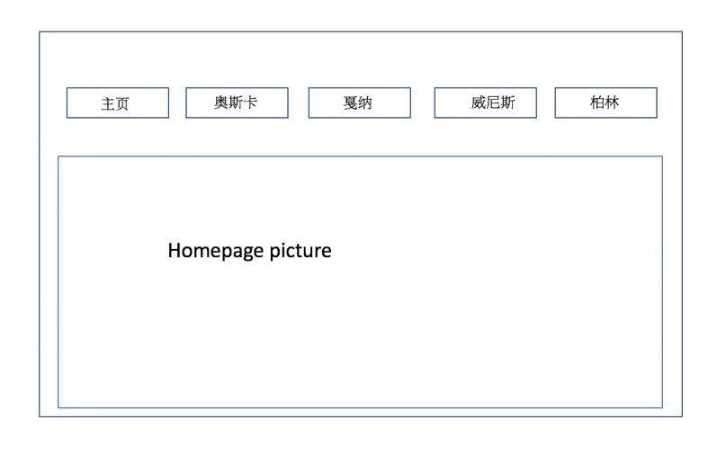

Figure 2. the former design (multi pages)

Since I choose to design a single page website, the web structure became very simple. I only need to consider the information presentation order. I tried to build small Wireframe of the site to test whether the design works or not. Wireframes are simple black and white layouts that outline the specific size and placement of page elements, site features, conversion areas and navigation for your website. There are five extremely important reasons outlined by Nick Haas, a creative director, on why we need to wireframe: Wireframes display site architecture visually; Wireframes allow for clarification of website features; Wireframes push usability to the forefront; Wireframes help make the design process iterative; Wireframes save time on the entire project.

In this project, because of the time limitation, I haven’t asked for anyone’s opinions about my web during the design period. But wireframe made the general design idea clear and complete.

(see figure 3)

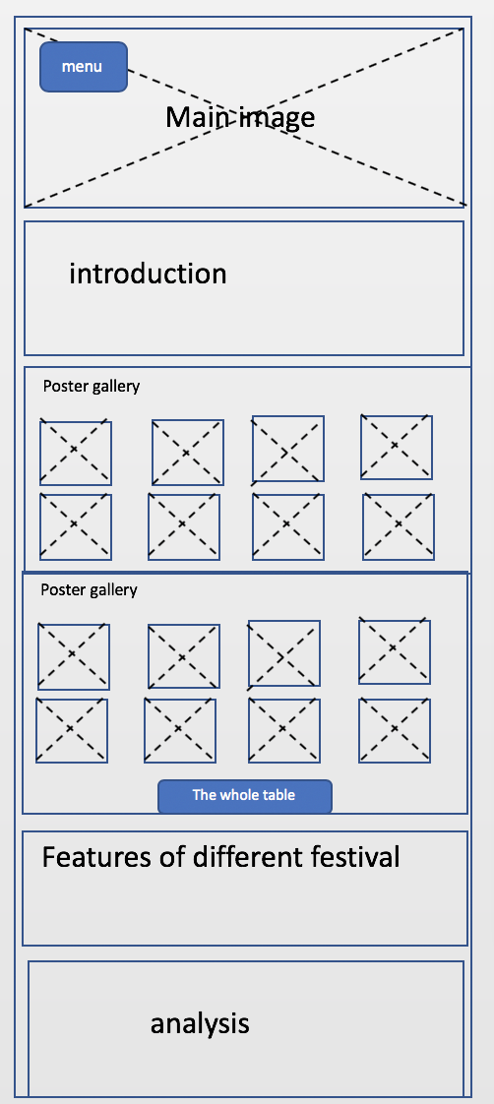

Figure 3

***Web Surface***

Web surface is a very important part of my project. It must be fantastic, artistic and cool to meet the expectation of my tasteful target audience. Considering about the movie theme, I picked several elements for my web: black, camera, high-definition image, unique navigation. Here are two example screenshots of my website (figure 4-6). And more details can be found at URL: <https://zoezhuoer.github.io/finalproject/>.

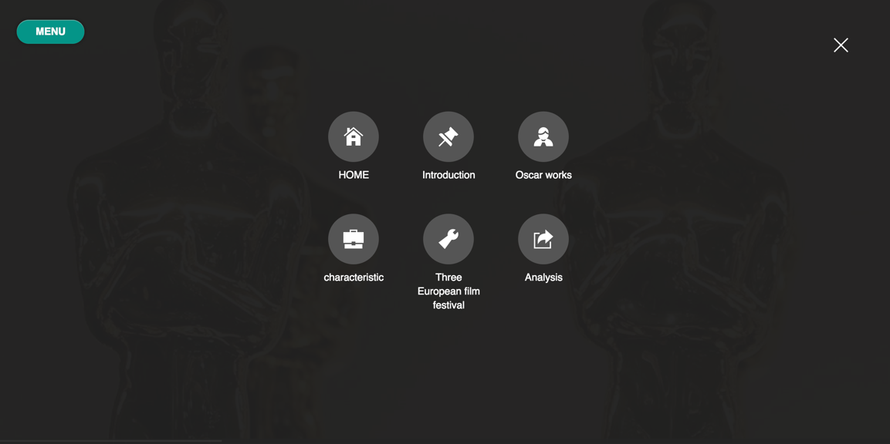

Figure 4 navigation

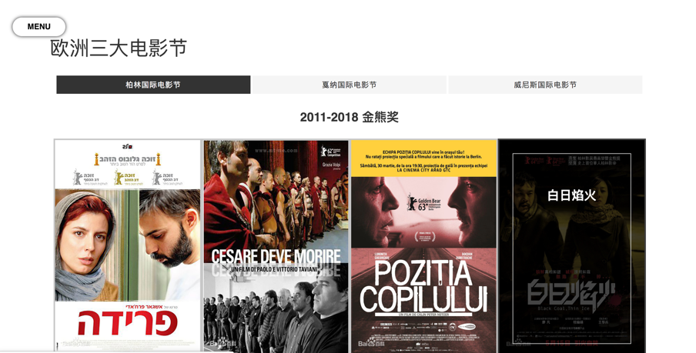

Figure 5 movies gallery

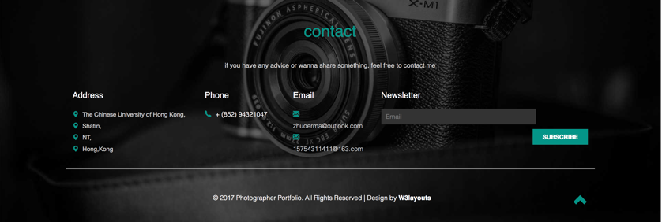

Figure 6 black and camera elements

***Usability Test***

Elaborate usability tests are a waste of resources. What I learned in this class is that the best results come from testing no more than 5 users because testing 5 participants reveals 80% of the problems and running as many small tests as you can afford.

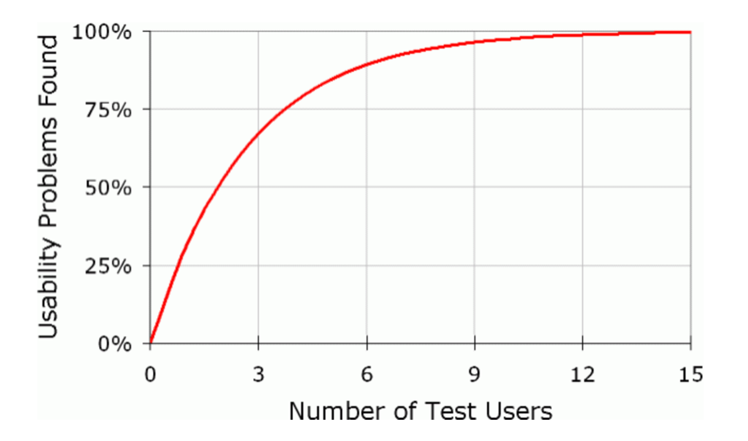

Figure 7

As is shown in the figure 7, testing 5 users is most efficient and economic. But you may find that testing 2 users can also find 50% usability problems, which maybe it’s more suitable for a student’s final project tests, who is much weaker and owns less resource than a startup. So I select 2 person as my usability testers: (1) my roommate, female, 24 years old, love documentary. (2) my cousin, male, 27 years old, love all kinds of movies.

I asked them to allow me to record the whole procedure, but they both thought that being filmed would let them nervous. So I step back and made a screen record.

Usability task and question list is shown below (Figure 8). Testers are asked to answer these questions or find some certain information on the web.

|  |
| --- |
| Task 1: find the movie gallery of “戛纳国际电影节” |
| Task 2: find the link to the official websites of these four film festivals. |
| Task 3: find out the age distribution of directors. |
| Task 4: find the form that displays all the movie information. |
| Task 5: which country won most prize in canvas film festival? |
| Question 1: what’s the meaning for the 4 scrolling pictures? |
| Question 2: what do you expect to happen when you click the movie poster? |
| Question 3: what’s the purpose of this website? |

Figure 8 Usability Test Question List

I thought my website is very simple and they can find all information very easily. However, the results disappointed me a little. They did finish the tasks but the procedure is not so smooth.

First, both of them haven’t found the navigation, which is truly a little secluded because I wanted to be well-designed, and they just scrolled the web. Maybe the button should be bigger. Second, they scrolled up and down in order to complete the tasks without logical thinking. They could finish it maybe just because there is not too much information on the web. Second, they didn’t understand the interactive charts in “Analysis” part (Figure 8). But they got to know it quickly after I show them. More introduction information needs to be placed on the web.

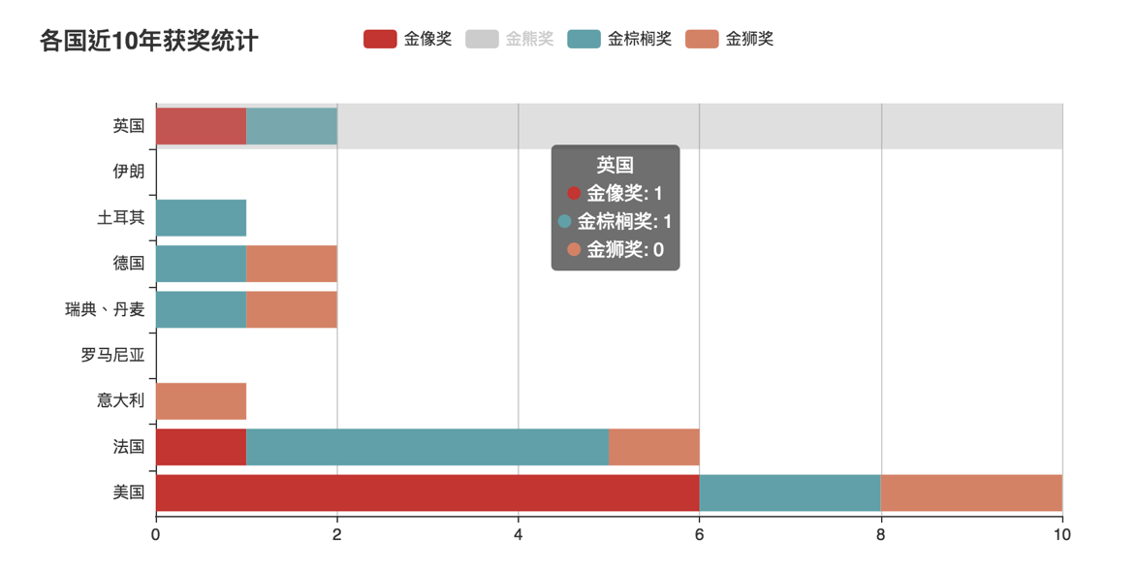

Figure 8 click “金熊奖”, the bar for it disappears

Then the three questions. Q1: The pictures which represent European top three film festivals confused them. Because they are not familiar with these three. Q2: they hope they can get the introduction of the movie and get the movie video immediately. Q3: They think the web is to introduce some films and film festivals for audience.

I find out I need to deal with many details of the web to make my audience easier to find the information. For example, give simply tips next to my interactive charts, make the navigation button more noticeable and so on. And I need to link more information to satisfy my users. Maybe it should link to movie online watching webs regardless of the copyrights.

***A/B Test***

A/B testing is comparing two versions of a web page to see which one performs better. Showing the two variants (A and B) to similar visitors at the same time and the one that gives a better conversion rate, wins! However, my web is just a simply one, so I use the time visitors stay in my web as the indicator to see if they are satisfied.

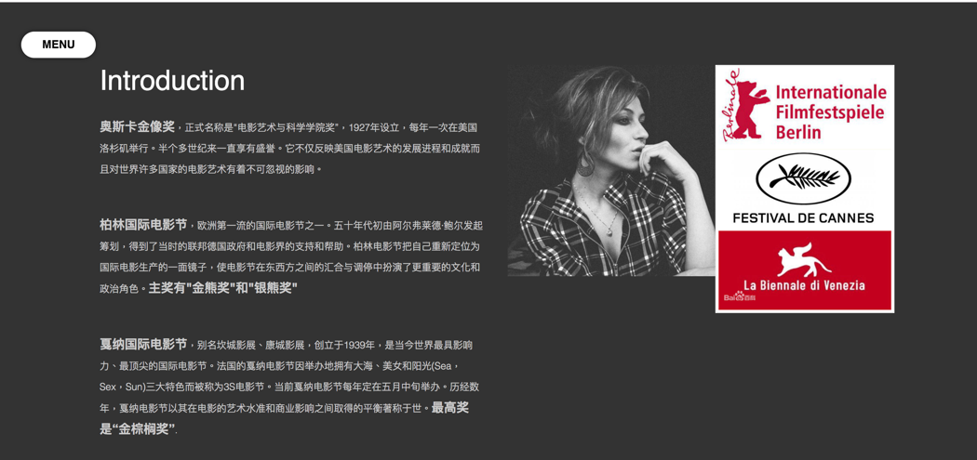

Figure 9 A/B test original



Figure 10 A/B test Variant B

The reason why I change the sub title of my web as variant B is that I found users may can’t get the main topic of the web at the first sight and the word “introduction” actually doesn’t reveal any information. Therefore, I changed the sub title into “奥斯卡与欧洲三大电影节”, which is clear and summarize the main content of the web.

The result shows that Variant B performs much better and visitors stayed longer. For original variant, the shortest time visitors stay is 42 seconds, while it improves to 1min 15 seconds in variant B. And the longest time grows from 2min 55 seconds to 4min 7seconds.

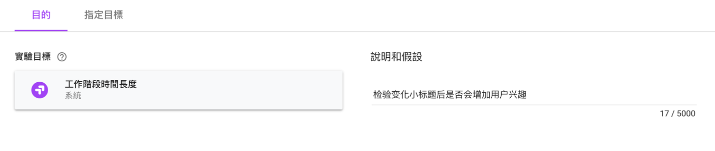

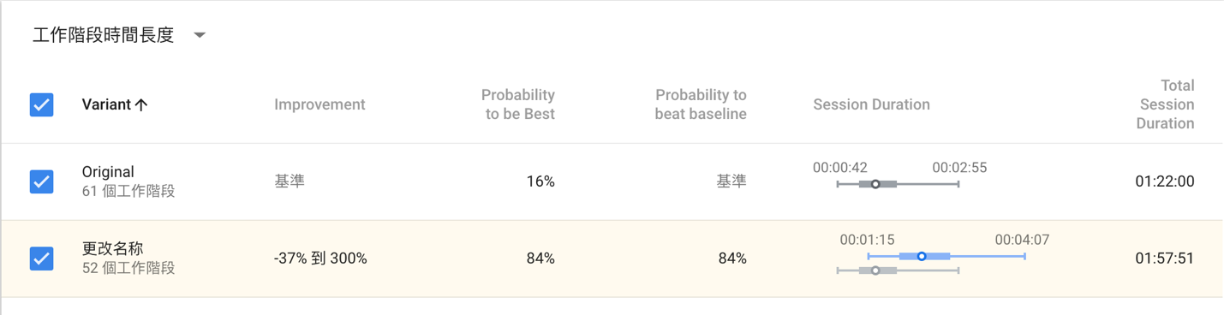

Figure 11 Optimize A/B Test Experiment

***Dashboard Design***

I created a dashboard on Google Analytics to get enough data on how my website is being used. We can see that 14.75% are returning users, higher than I expected. And most visitors are from HK and mainland. The bounce rate is really high. Two possible reasons: first, most visitors are my friends and click the web just to help me. Second, my web is too simple, visitors can look through the whole web without click anything.

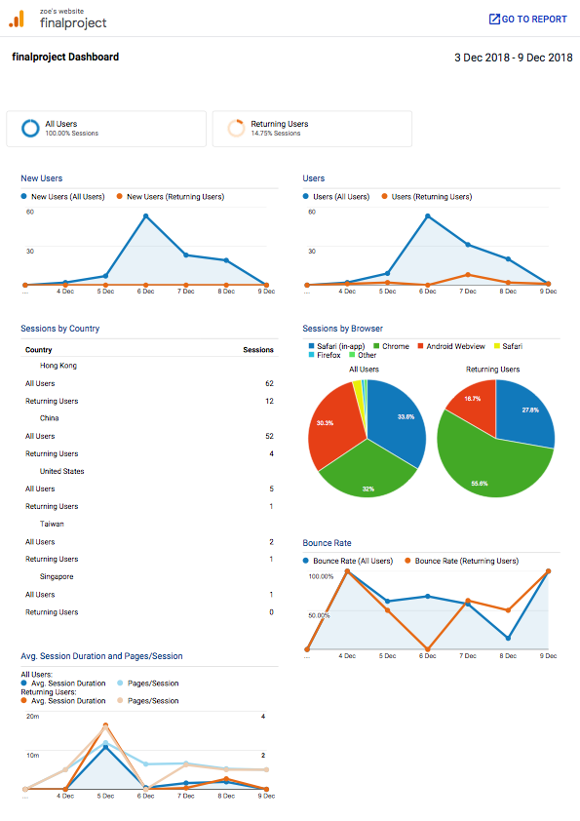

Figure 12 google analytics dashboard

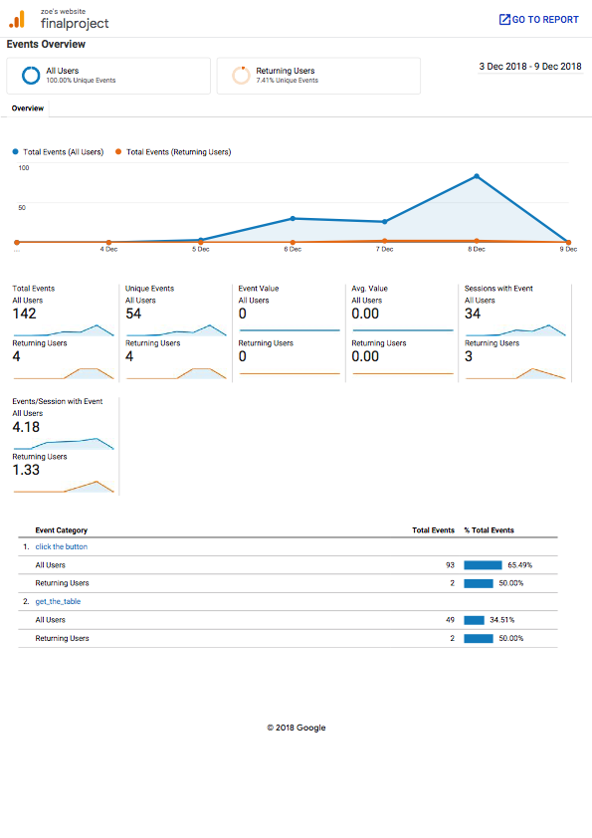

Figure 13 google analytics events overview

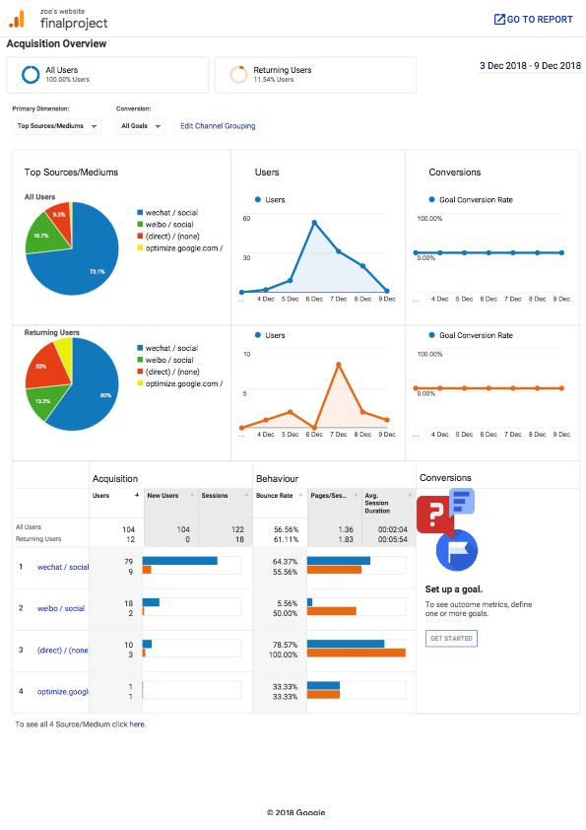

Figure 14 google analytics Acquisition Overview

And I set two events to monitoring: “click the button” (the navigation button) and “get the table” (the button to get data from airtable). And the result is shown in the figure 13.

I promote my web in two ways: weibo and WeChat. And figure 14 shows the visitors sources very clearly. Most of my visitors are from WeChat platform.

***Conclusion***

To be honest, when I started to do this project, I still didn’t have much product design thinking. The idea to design this web is more like designing a blog which try to attract audience. After communicating with my classmates, I found out a product need to solve a problem first and web design, data collection, tracking the web are just the method to achieve the goal. Watching movie is something people usually do in their leisure time, and they may feel unhappy when they watch a bad movie or they can’t participate in an elegant movie talk because of the lack of background knowledge about top film festivals. It can be a pain point but not very pain, I suppose.

If I can design the web again, I will choose the fans of these four film festivals as my target audience and provide more professional information, put some excellent film reviews in and add some social function.